

**DIGITAL INNOVATORS PROGRAMME(DIP)**

**COMPUTER SCIENCE | PSCS 2014**

**COMPUTER SCIENCE**

**SEMESTER 2 PART 2**

**TASK 3 (10% CARRYMARKS)**

**SQL EXERCISE : LIBRARY DATABASE**

**PREPARED BY:**

NAME: ABDUL LATHEEF FAUZAN BIN MUHAMAD NAJIB

CLASS: 1K6

### **TABLE OF CONTENT**

**TABLE OF CONTENT 2**

**1.0 Technologies Used 2**

**2.0 Database Structure 3**

2.1 Creation Of Database 3

2.2 Table Creation 3

**3.0 Data Management 3**

**4.0 Query Operations 4**

4.1 List And Find Books Query 4

4.2 Update Query 4

4.3 Delete Query 4

**5.0 Results Documentation 5**

5.1 Original Result 5

5.2 Result After Delete Book 5

5.3 Result Re-add a Deleted Book 5

### 

### 

### 

### **1.0 Technologies Used**

The technology used for this task is TablePlus, a tool for managing MySQL databases, providing user-friendly interfaces to interact with, query, and manipulate the database content.

### 

### 

### 

### 

### 

### **2.0 Database Structure**

#### 

#### 2.1 Creation Of Database



The name for the database is library_db

#### 2.2 Table Creation

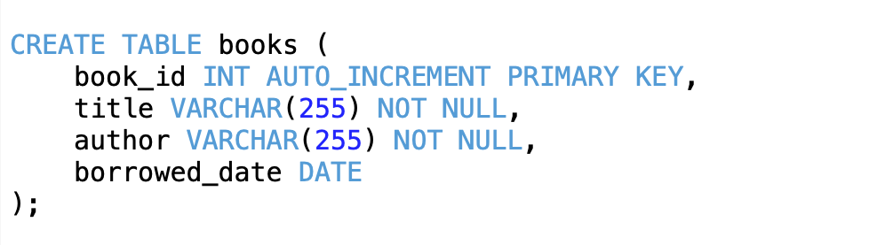

Table name is books

### **3.0 Data Management**

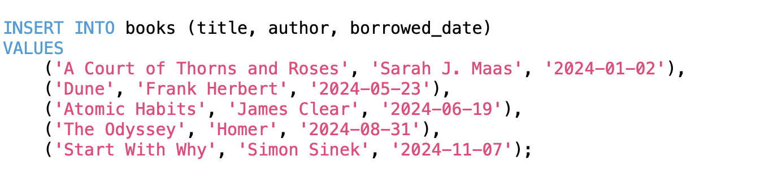

### 

### **4.0 Query Operations**

Query operations allow interaction with the database to extract useful information. The library database supports the following queries:

#### 4.1 List And Find Books Query



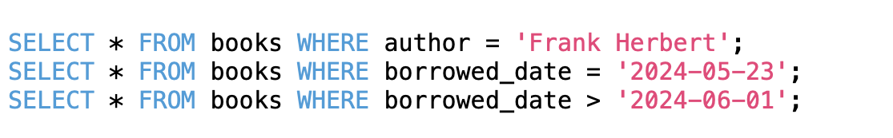

#### 4.2 Update Query



#### 4.3 Delete Query



### 

### 

### **5.0 Results Documentation**

#### 5.1 Original Result

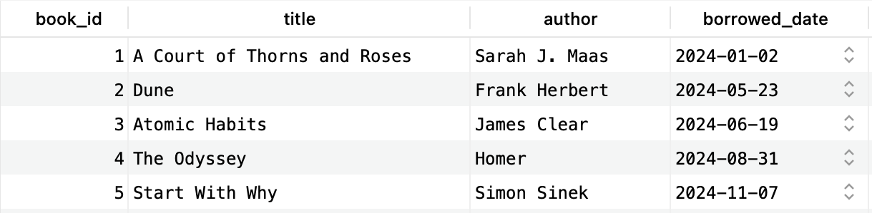

#### 5.2 Result After Delete Book

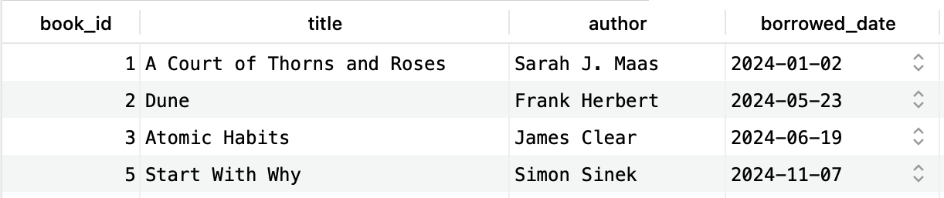

#### 5.3 Result Re-add a Deleted Book

